Flipbook example

This is an example of how to make a flip book from a video. This example uses the video titled Fractions from Teacher Tube.

By Jordan O’Quinn



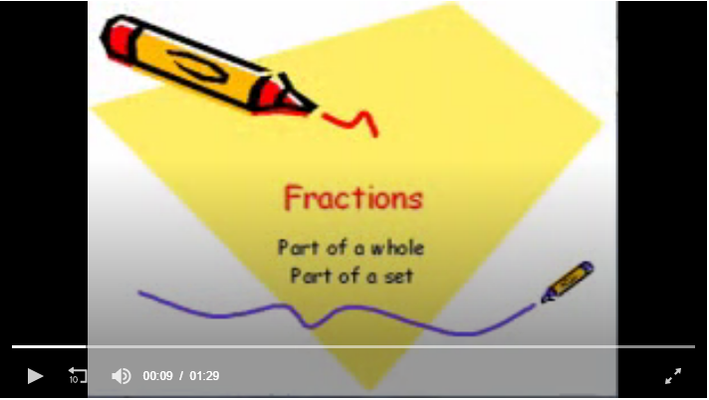

Fractions can show a part of a whole or a part of a set

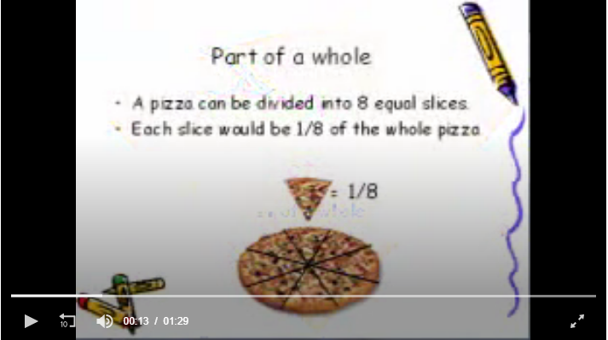

A pizza can be divided into eight equal slices, each slice would be 1/8 of the whole pizza

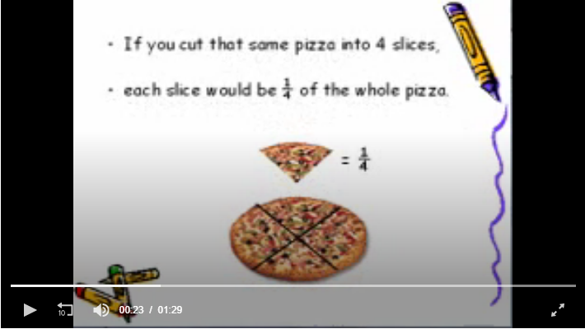

If you cut the same pizza into four slices, each slice would be ¼ of the whole pizza

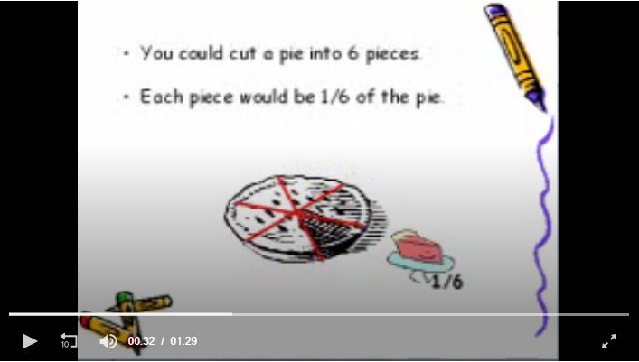

You could also cut a pie into six pieces; each piece would be 1/6 of the pie.

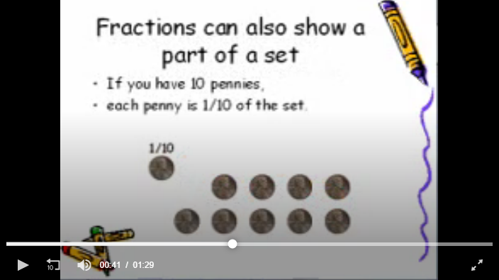

Fractions can also show part of a set. If you have 10 pennies, each penny is 1/10 of the set.

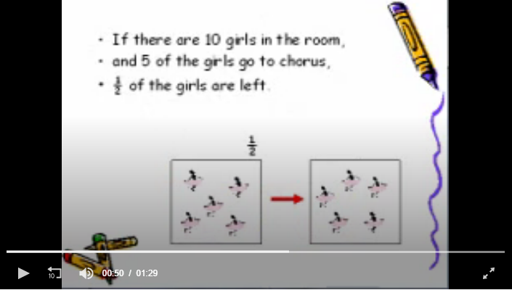

If there are ten girls in the room, and five of the girls go to chorus 1/2 of the girls are left.

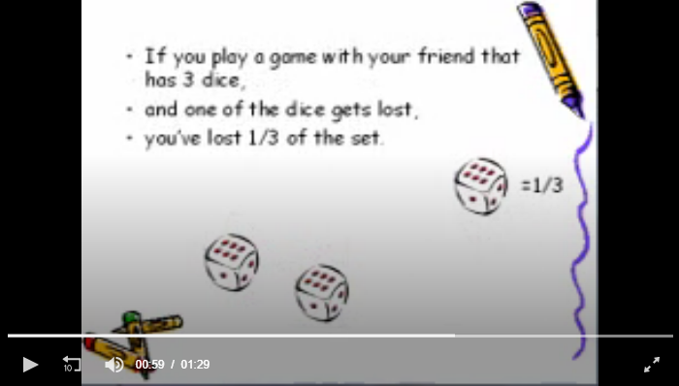

If you play a game with your friend that has three dice, and one of the dice gets lost you’ve lost 1/3 of the set.

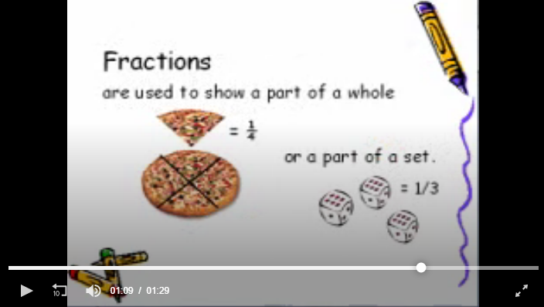

Fractions are used to show a part of a whole or part of a set